Day 4 – Kanban + Filters (JQL)
Learn
- Kanban board purpose
Kanban is used for continuous workflow where tasks are not planned in fixed sprints. It is mainly used for support projects, maintenance work, and production issues where work comes continuously.
- Continuous delivery concept
In Kanban, issues move continuously from To Do → In Progress → Done without waiting for sprint completion. This helps teams deliver faster and respond quickly to changes.
- JQL fundamentals
JQL is used to search issues in Jira based on conditions like assignee, status, priority, project, labels, due date, and text fields.
Practical
- Created a Kanban project
Created a Kanban project with a name Practice Kanban (PK) in Jira Software.
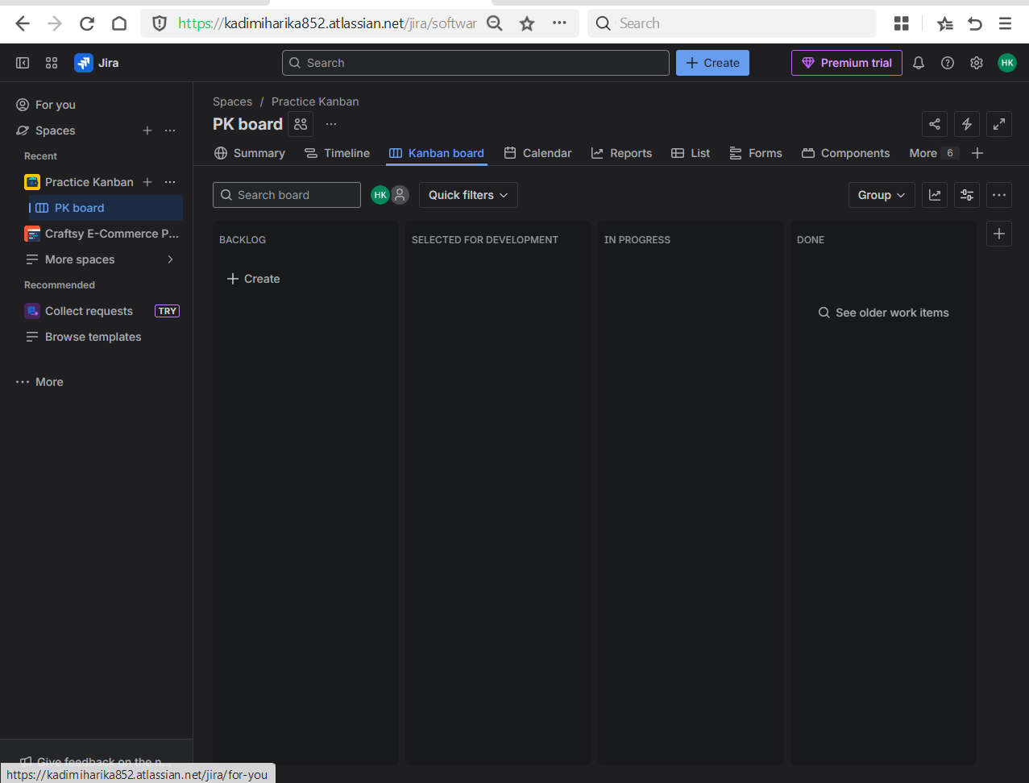
- Created issues and move them
Created multiple issues such as Stories, Tasks and Bugs.
Moved issues across kanban columns to simulate real-time project flow.
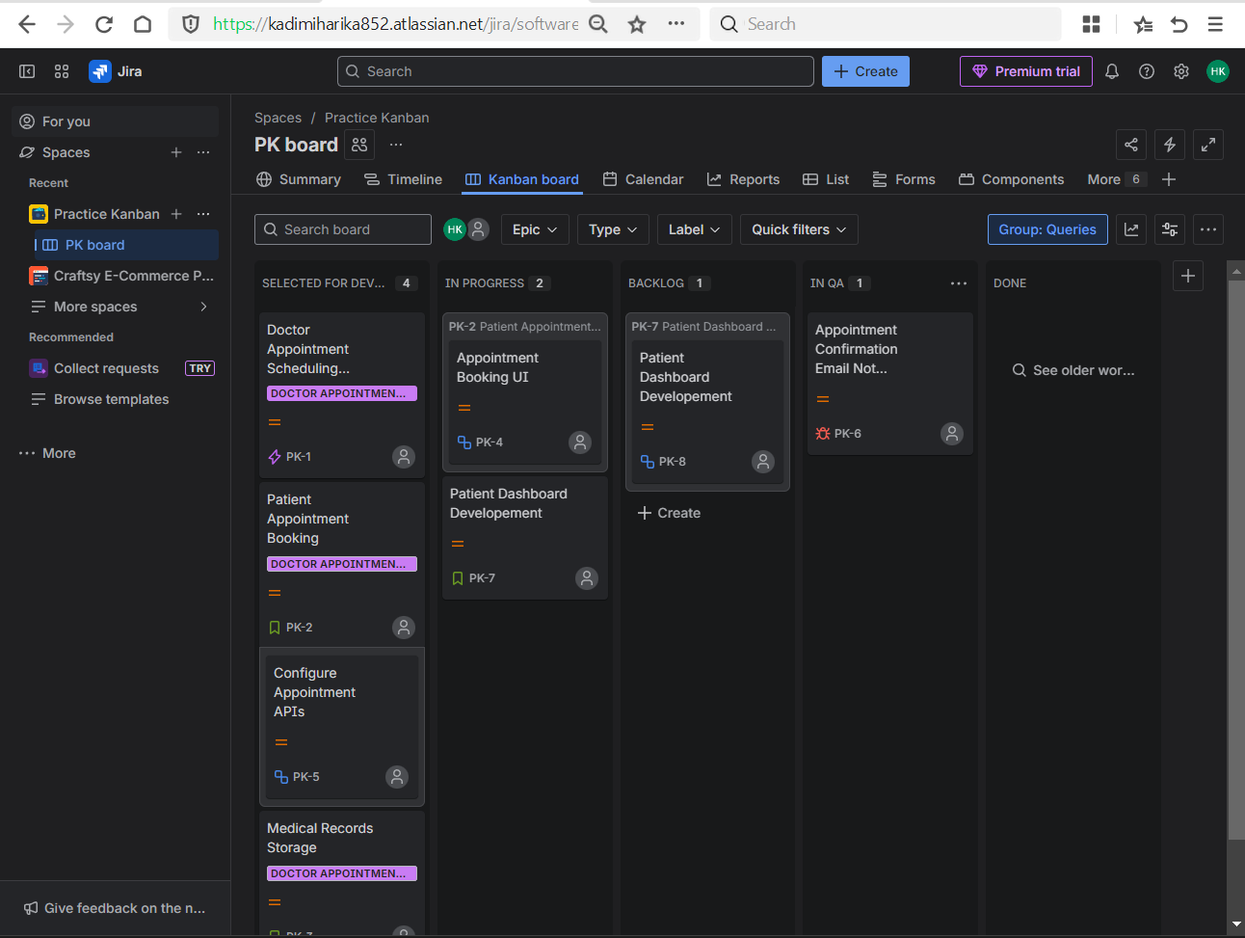
- Used JQL:
    - Issues assigned to me
Used to check my own workload.
assignee = currentUser()
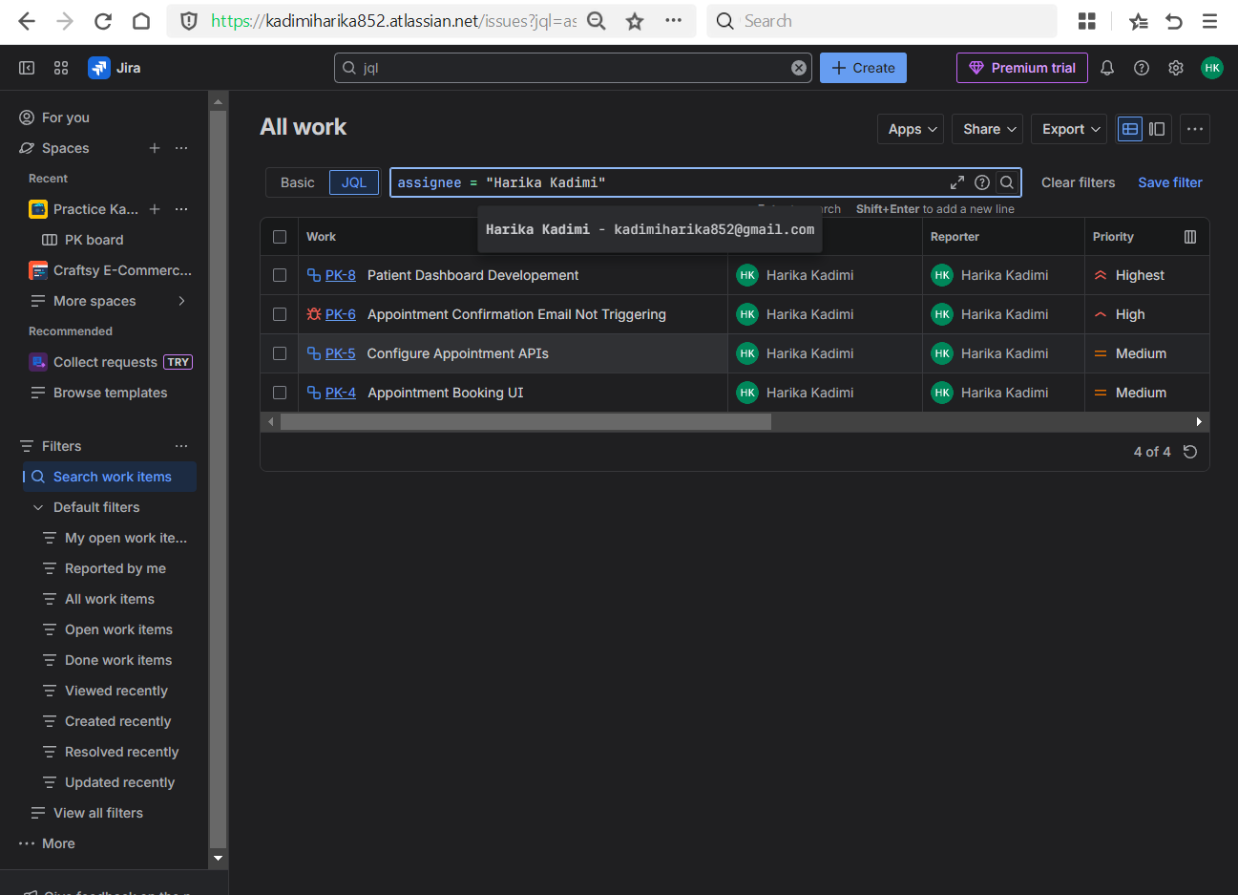
    - Issues not completed
Used to track pending work.
status != Done
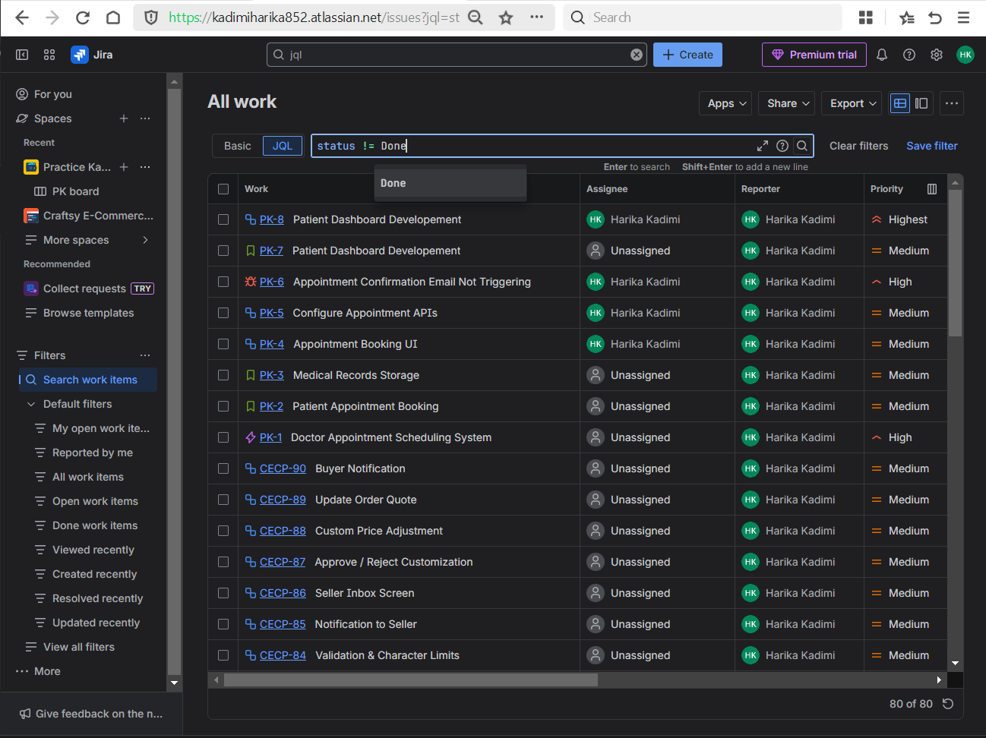

    - High priority issues in a specific project
Used by leads to monitor crtitical tasks.
project = “ProjectName” AND priority = High

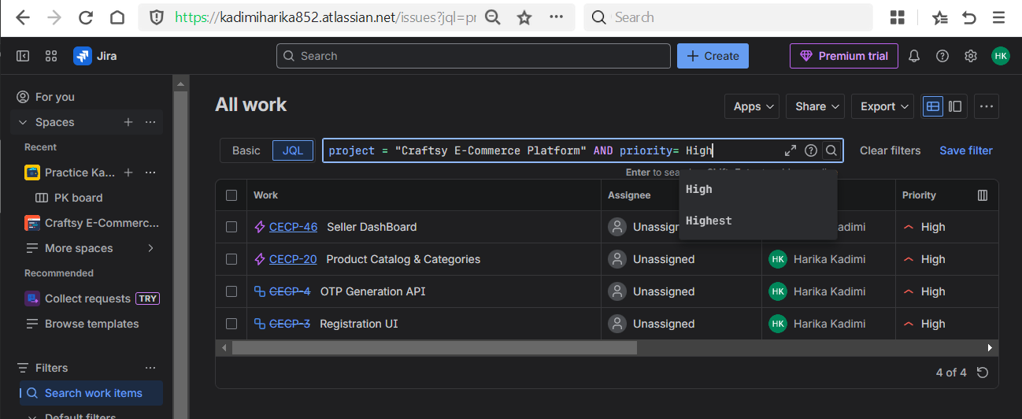

    - Taks due this day
Used to track upcoming deadlines
due <= endOfDay()

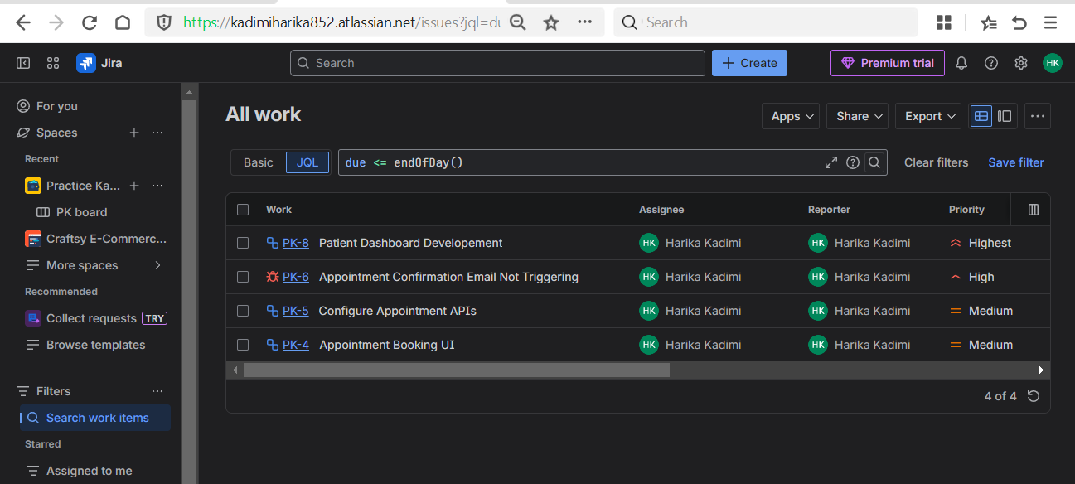

    - All progressing tasks
Used to view work that has started and are currently employees working on
status = “In Progress”
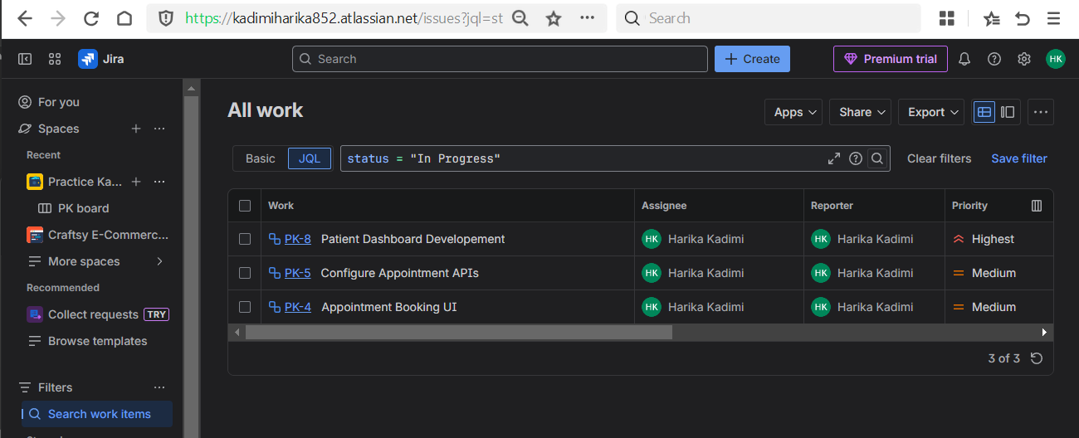

- Combined Conditions

    - High priority and not done
Used to identify urgent unfinished work
priority = High AND status != Done

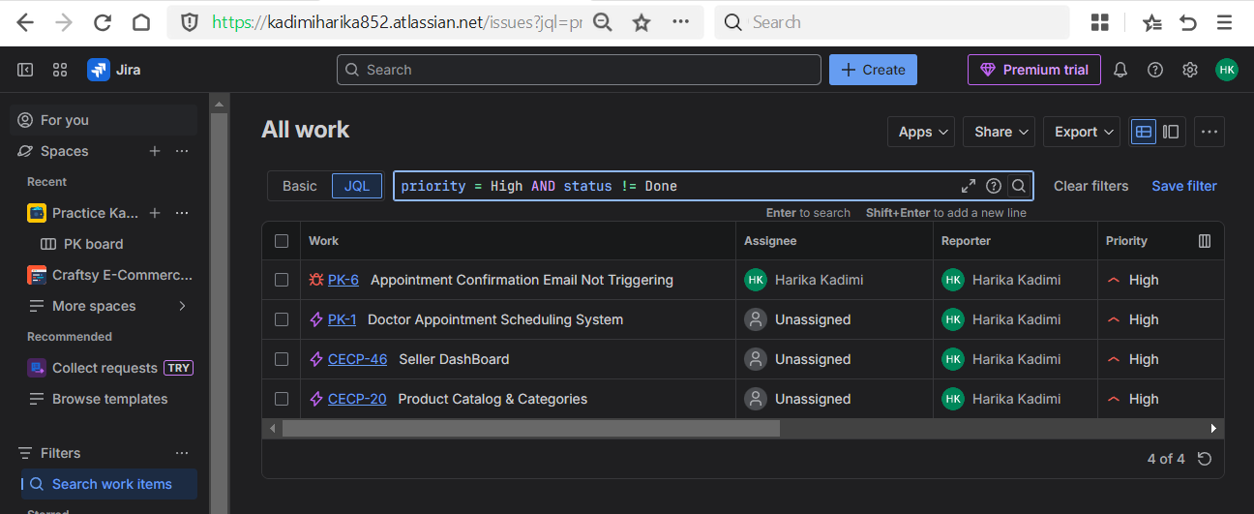

    - Assigned to Harika and In Progress
Used to track individual progress.
assignee = “Harika Kadimi” AND status = “In Progress”

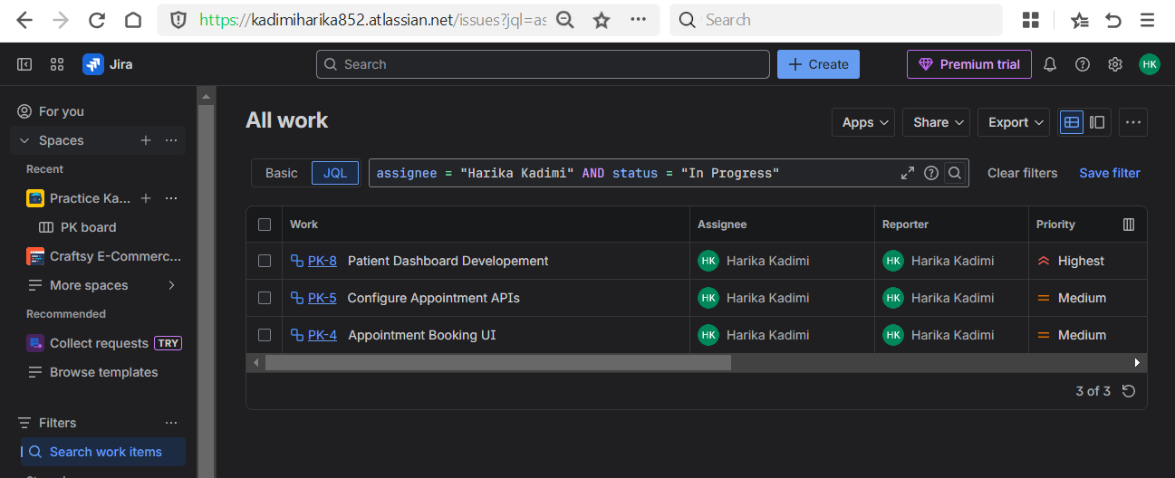

    - Issues with backend label
Used to filter bakend-related issues
Labels IN (backend)
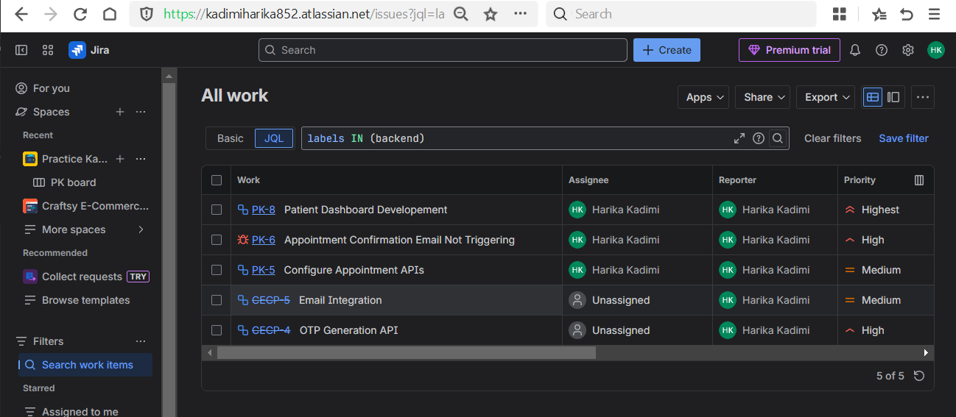

    - Summary containing keyword
Used for quick issues search based on the summary containing specified keyword
Summary ~ “keyword” // testing

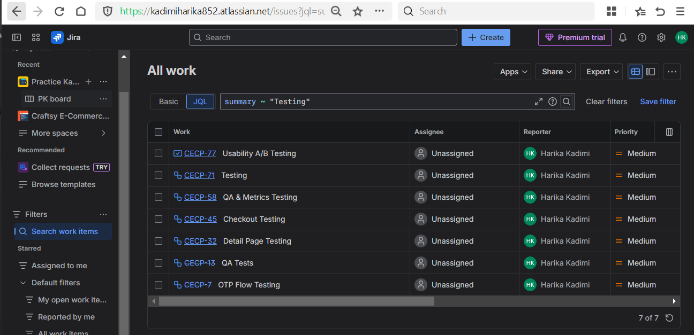

Summary ~ “keyword” //App

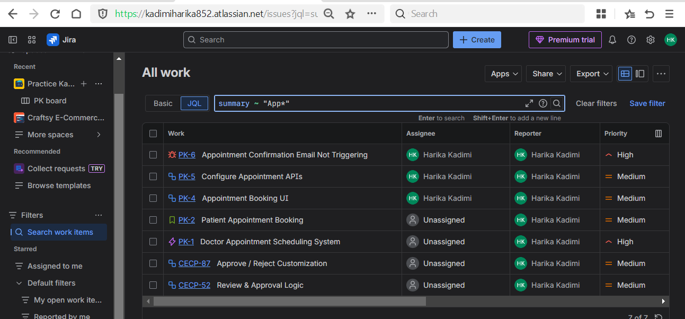

    - Description containing keyword
Used to search the issues that are containing the description with a specified keyword.
description ~ “keyword” // request

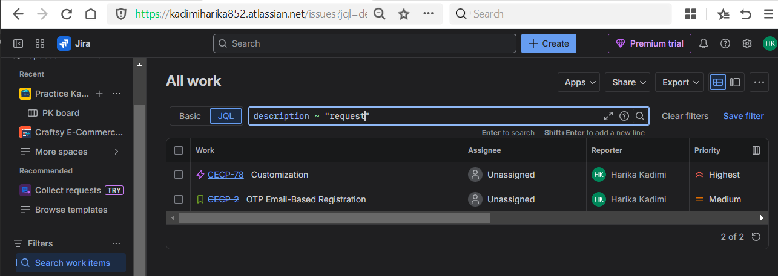

    - All due before a data
Used to find the issues that are in mentioned date
due <= “Date” // “2025-01-03”

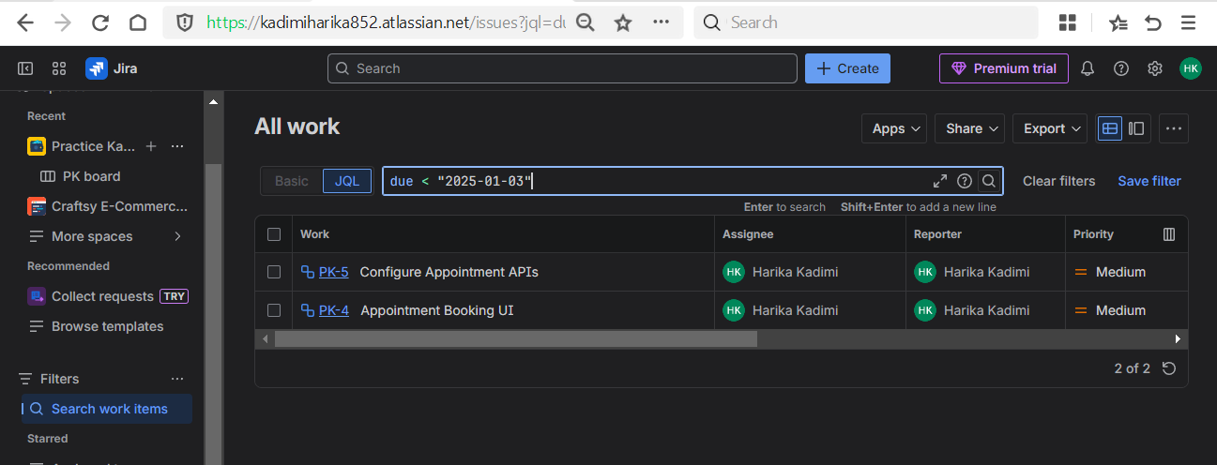

    - Issues with no assignee
Used to find unassigned work.
Assignee IS EMPTY
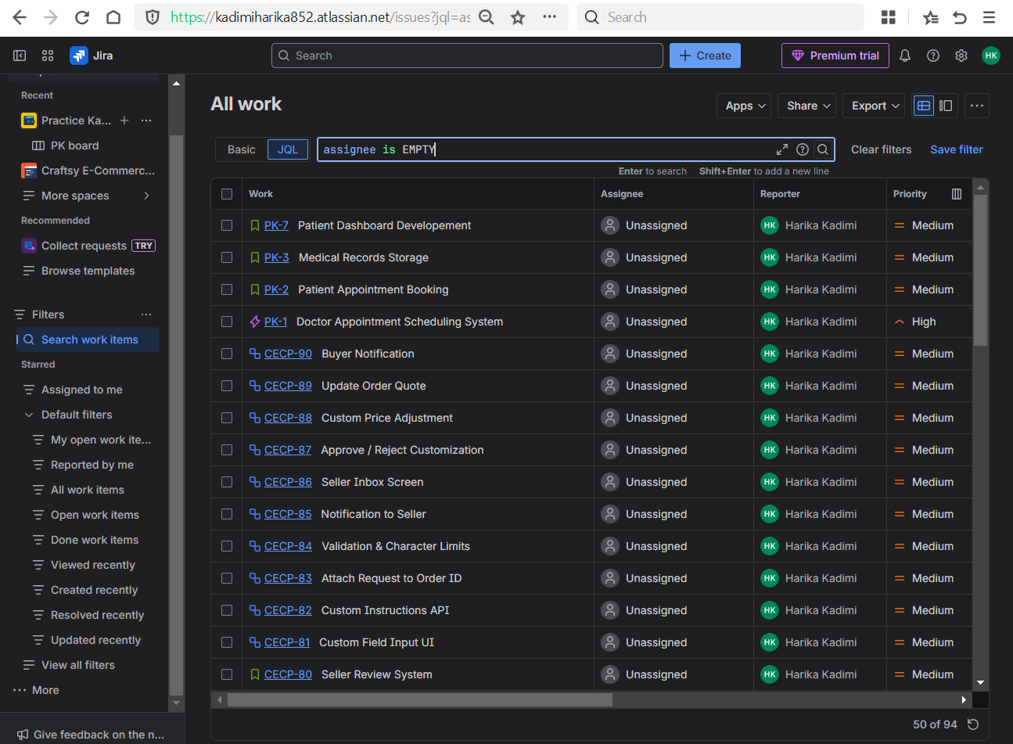

    - Issues assigned to multiple users
Used for team-level tracking.
Assignee IN (“Harika Kadimi”, Priya)

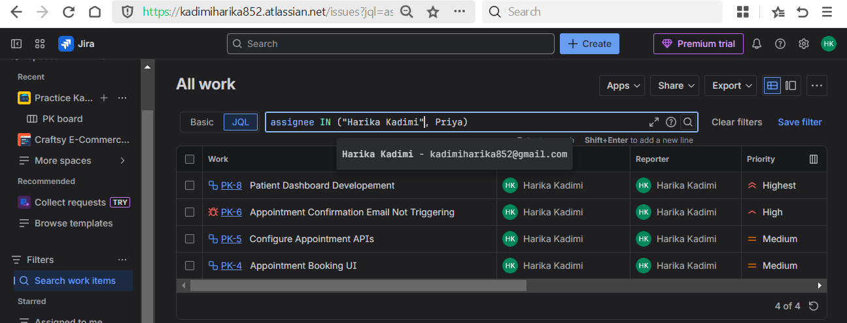

    - Highest or High priority unfinished issues
Used for risk and escalation tracking.
(prioiry = Highest OR priority = High) AND status != Done

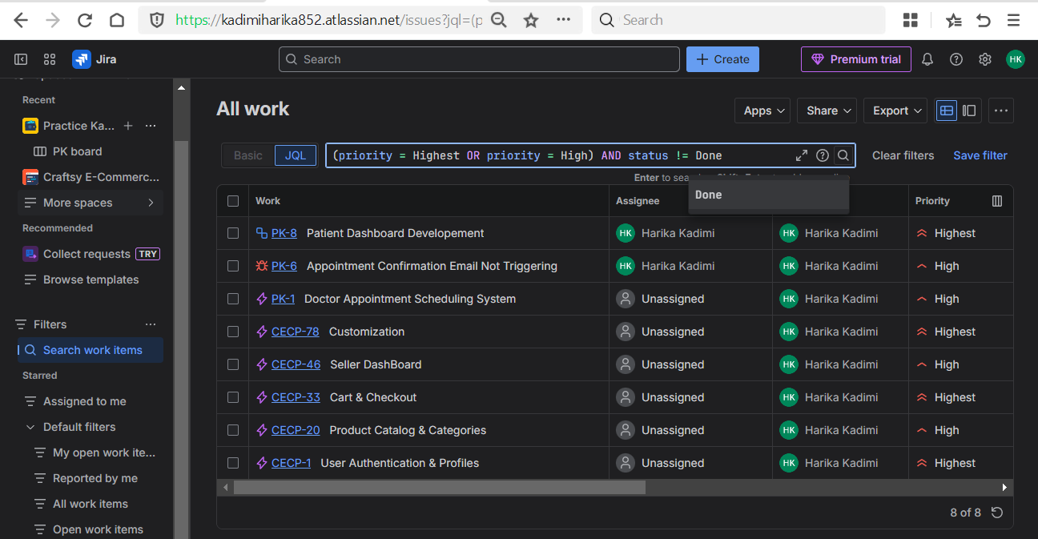

    - Filter by multiple lables
Used to filter the issues quickly using multiple lables.
Labels IN (frontend, backend, setup)

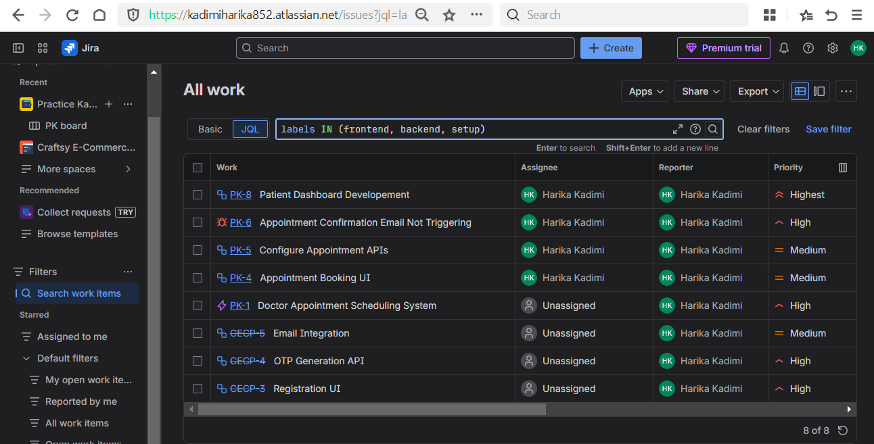
- Saved filters
Used to save the filters for quick access of specific issues.
